GROUP MEMBERS

* MESHACK NEHEMIA EB3/56465/21
* HEUDIA JEPKORIR EB3/56432/21
* JOHN KYALO EB3/56374/21
* WINROSE KIRISWA EB3/56314/21
* DIANA CHELANGAT EB3/56426/21
* FAITH JERONO EB3/56420/21
* PRISCILLA NJERI EB3/56404/21
* ARNOLD MWAI EB3/37770/18
* JONATHAN MULINGE EB3/56664/21
* ANTONY MWANGI EB3/56342/21

The system should be able to perform the following tasks:

1. Allocate students courses
2. Allocate lecturer courses
3. Get course scores
4. Generate student result slip with each course’s code, title, score and grade and average and average grade
5. Generate a report showing the lecturers allocated various units
6. Allow a lecturer to search the courses allocated and see them on the display window
7. Allow searching for student, lecturer, student courses, lecturer courses, etc.
8. Use a MySQL database management system to store and retrieve data
9. Administrator to add student, lectures, librarian and their fellow admins
10. Admin to allocate courses
11. Student to do only one program containing 5 units
12. Admin to add units and to allocate program unites
13. Librarian to approve the books and add new books
14. Admin can add books also
15. Admin to validate the exams when the lectures have entered the marks
16. Admin can search all student books lectures and librarian
17. Admin, students and lectures can borrow books but needs the approval of the librarian
18. Students can search the book, librarian can search the student and books, also as the lecture
19. The program requires nice user Interface that has four logins in.

**ACTORS:**

1. Student
2. Lecturer
3. System Admin
4. Librarian

**USERCASES:**

Login

Allocate Course to Program

Allocate Course to Lecturer

Get Course Score

Generate Student Result Slip

Generate Lecturer Course Report

View Allocated Courses (for Lecturer)

Search for Student, lectures, Student, Courses

Validate exams

Enter marks

Add students lectures librarian and admins

Can remove the above

Remove or add program and courses

View the report

Validate exams

**DOMAIN OBJECTS:**

1. USER (base class for Student, Lecturer)
2. Student
3. Lecturer
4. Course
5. Score
6. Books
7. Librarian
8. borrowedBooks
9. admin

**USERCASE DIAGRAM;**

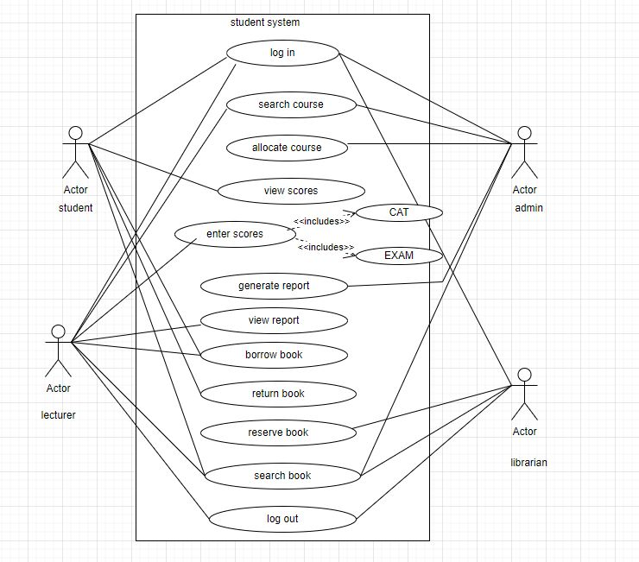

**OBJECT EXPLANATION.**

PROJECT ANALYSIS

ADMIN CLASS

This class contains many operations connected to database it works in such a way that the Admin can allocate courses and programs to both student and lecturer, add lecturer, student and librarian to the system. Admin can also search, delete, update programs and validate student results.

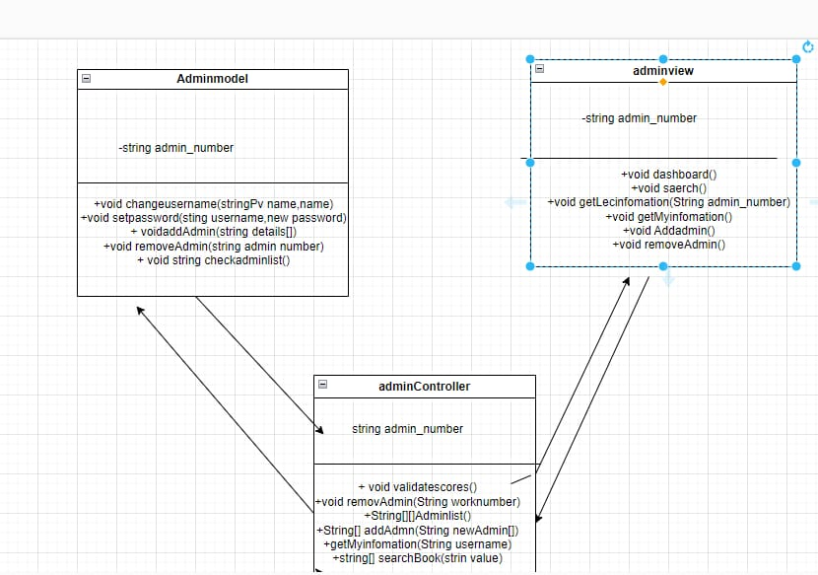

USER CLASS

This is a class that allows you to login either as a student, lecturer, admin or a librarian. Moreover, it allows you to change password in case you forgot. Also for added advantages it has the error detection it detects the mistake that has occurs and it notifies you. through highlighting the place with red ink and specifies in top coner;

LECTURER CLASS

This class contains many operations that are connected to a database which works in a way that a lecturer can enter marks of students, search and borrow books from the library. Lecturer can also search courses he/she is allocated to.

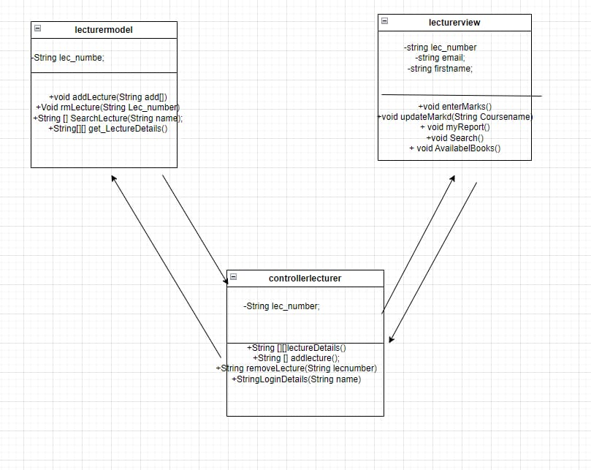

STUDENT CLASS

This class contains operations that are connected to a database. The operations of the student can include searching, borrowing and reserving books from the library. Student can view Cat and exam marks from the result slip. Moreover, student can search courses and programs.

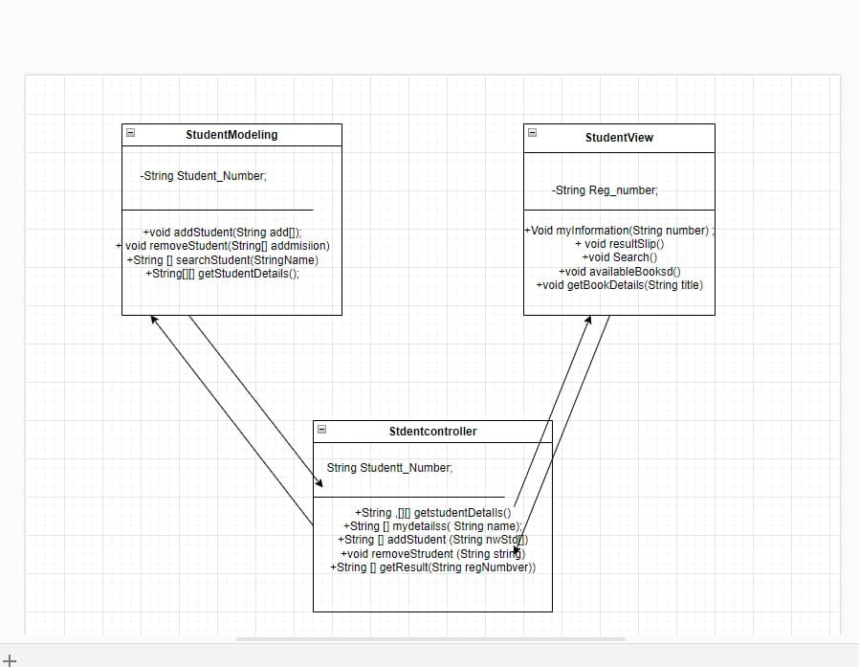

LIBRARIAN CLASS

This class enables the librarian to approve the student, Lecturer and admin who are either borrowing, reserving or returning book to the library.

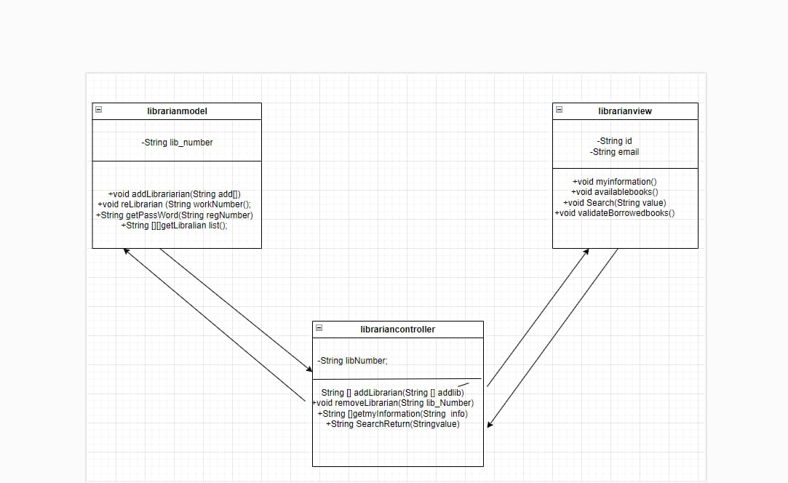

***Class diagrams***

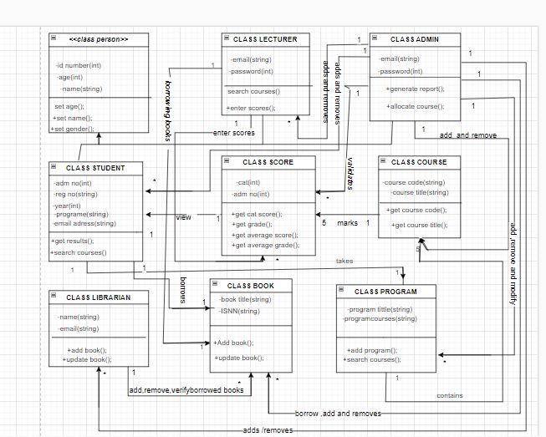

***ACTIVITY DIAGRAM***

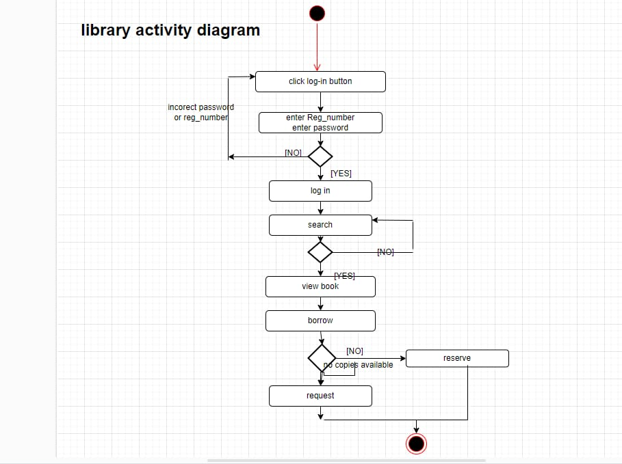

**SEQUENCY DIAGRAM.**

